*'''  
Generate requirements.txt file using pip command from terminal  
'''*

1) #Using Pip freeze command:pip freeze

Pip freeze , lists down all installed packages that can be bundled into requirements

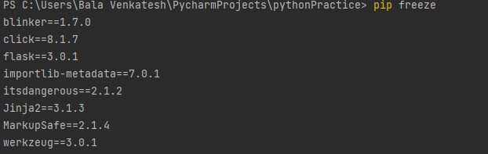

2) pip freeze > requirements. txt

Generates text file , with list of installed packages which can be used for installing packages in other environments.



